Upcoming Bell Events!
December 17-21, 2018
MONDAY  12/17 | TUESDAY  12/18 | WEDNESDAY  12/19 | THURSDAY  12/20 | FRIDAY  12/21
Wear Red & Green!  GSA meeting in room S2  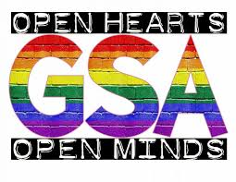 | Wear Christmas socks!  CJSF meeting in room S2  After school sports (soccer and volleyball) | Ugly Christmas sweaters!  Collaboration Early Release  Pentathlon meeting at lunch  Basketball Tournament final today at lunch | Wear Santa Hats!  Book club meeting in the library!  After school sports (soccer and volleyball) | Wear a Flannel!  Animal Amigos M1 at lunch  Music at lunch if campus is clean  See you all next year!  Happy Holidays!

